Customer Shopping Behavior Analysis
- Project Overview
This project analyzes customer shopping behaviour using transactional data from 3,900 purchases across multiple product categories. The objective is to uncover insights into customer preferences, spending patterns, and subscription behaviour to support data-driven business decisions.
- Dataset Summary
Row:3900
Column: 18
Key Features: - Customer demographics (Age, Gender, Location, Subscription Status) - Purchase details (Item Purchased, Category, Purchase Amount, Season, Size, Color) - Shopping behaviour (Discount Applied, Promo Code Used, Previous Purchases, Frequency of Purchases, Review Rating, Shipping Type)

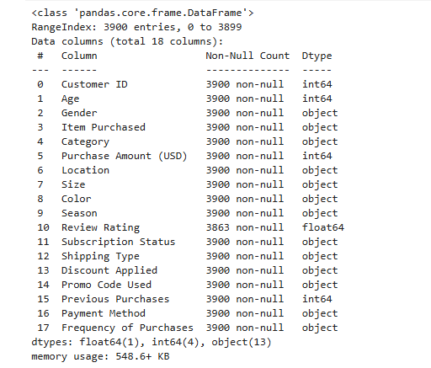

- Exploratory Data Analysis (EDA)
EDA was performed using Python (Pandas, NumPy, Matplotlib) to clean the data, handle missing values, and analyze distributions of age, gender, purchase amount, product categories, and review ratings. Key trends such as high-performing categories and customer spending behavior were identified.

Missing Data Handling: Checked for null values and imputed missing values in the Review Rating column using the median rating of each product category.
Column Standardization: Renamed columns to snake case for better readability and documentation.
Feature Engineering: Created age_group column by binning customer ages.
Created purchase_frequency_days column from purchase data.

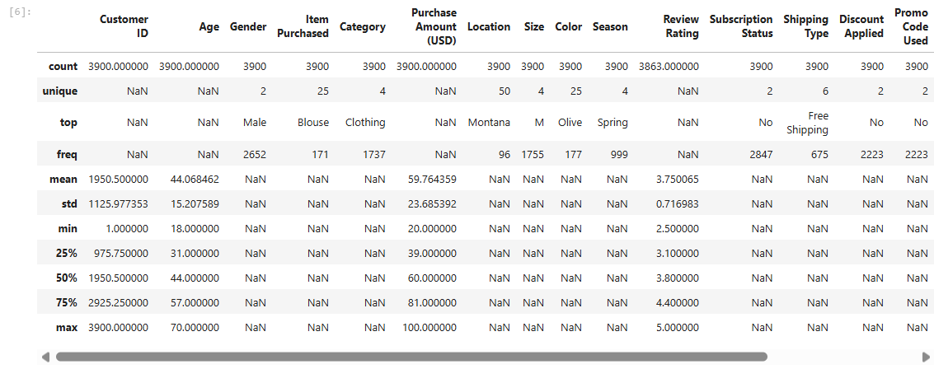

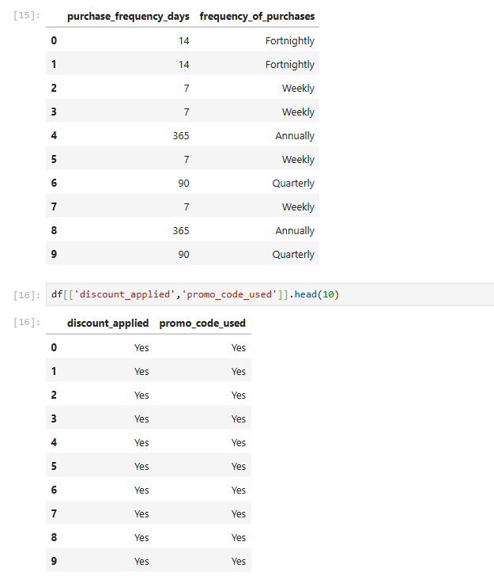

- SQL Analysis
The cleaned dataset was loaded into a MySQL database. SQL queries were used to analyze top-selling products, average ratings by item, customer segmentation, purchase frequency, and subscription impact on spending. Aggregations, filtering, grouping, and sorting helped derive actionable insights.

- Dashboard Creation (Power BI)

An interactive dashboard was developed using Power BI to present key business insights in a clear and visually engaging manner. The dashboard displays important KPIs such as total sales, average purchase value, top-performing products, category-wise sales distribution, and customer demographics. Multiple visual elements, including bar charts and cards, were used to highlight trends and comparisons. Interactive slicers and filters allow users to dynamically analyze data by product category, gender, age group, and subscription status, enabling deeper insights and informed decision-making.

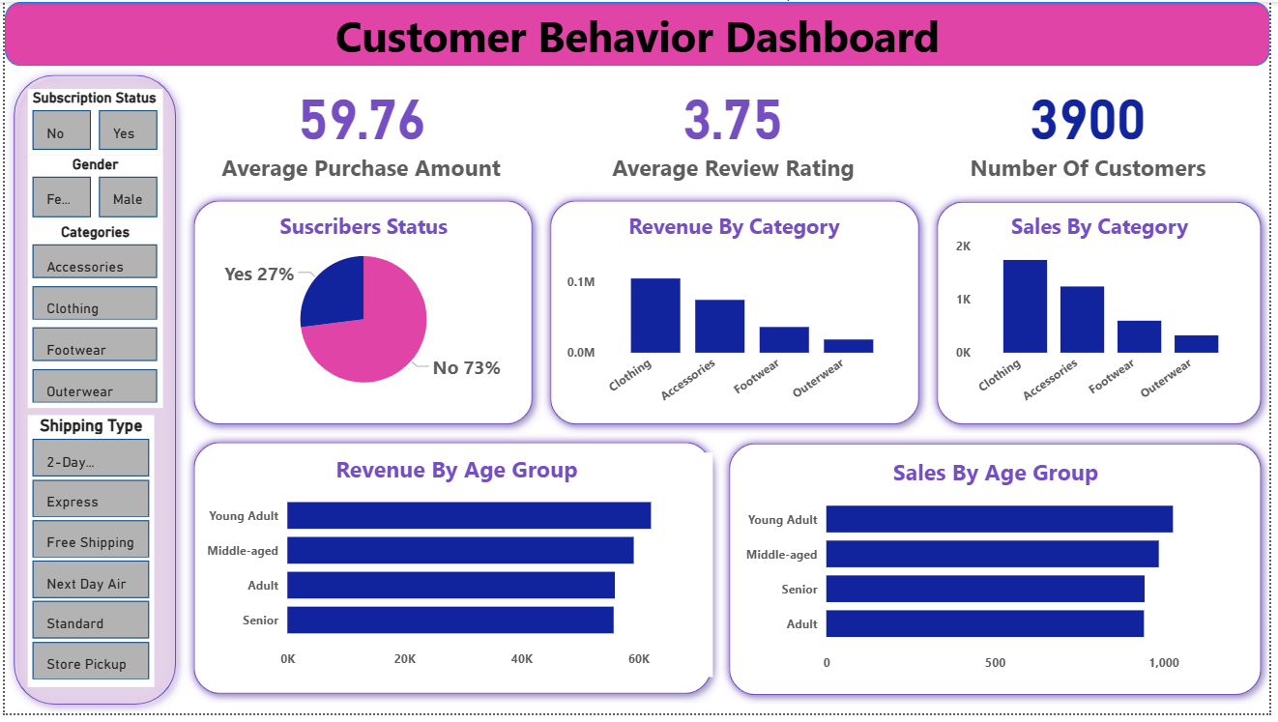

Conclusion:

This project demonstrates an end-to-end data analytics workflow, integrating Python, MySQL, SQL, and Power BI to convert raw transactional data into actionable business insights.

Recommendation:
Boost subscriptions through exclusive benefits, implement loyalty programs to retain repeat customers, optimize discount strategies, highlight top-rated products, and focus targeted marketing on high-revenue age groups and express-shipping users to maximize customer retention, sales growth, and overall business profitability.

